Pathways Housing Scout

The goal of our project is to create an online tool for scouting locations to resettle refugees in Fulton and Dekalb counties GA.

[Link to Tool](https://dssg-pathways.shinyapps.io/Refugee_Resettlement/)

[Project GitHub](https://github.com/uahsan3/NAP2016)

Primary Selection Criteria

1. Price

2. Proximity to Public Transit

3. Public Safety

Secondary Selection Criteria

1. Proximity to schools, grocery stores, faith centers, and other community facilities

2. Distance to New American Pathways HQ

3. Access to jobs & retail

Data We've Collected

* All Apartment Buildings in Fulton and Dekalb Counties
* Index data on affordability, job access, and retail access
* Crime data
* Faith Centers
* Grocery stores and markets
* Schools
* ESL resources
* MARTA transit stops
* Hospitals
* DFACS
* SSN offices

Additionally, the dynamic weighting feature can be used to create a comprehensive heat map of Dekalb and Fulton counties which color areas based on multi-input criteria. This feature allows the user to define 'ideal' and create a custom map.

Finally, there is a short tutorial on how to update the apartment listings.

Apartment complex locations in Dekalb & Fulton County

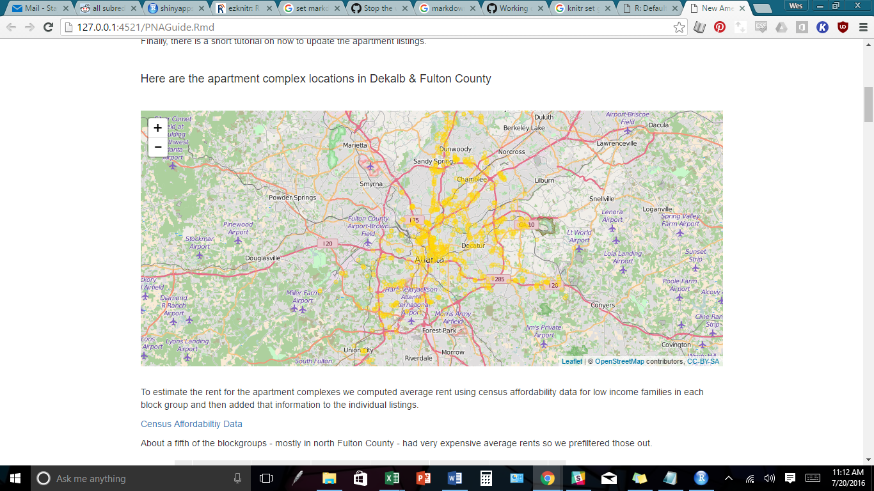

To estimate the rent for the apartment complexes we computed average rent using census affordability data for low income families in each block group and then added that information to the individual listings.

[Census Affordability Data](http://arc.garc.opendata.arcgis.com/datasets/27b53ea69f98474eb002ac3b9c6b51eb_0)

About a fifth of the block groups - mostly in north Fulton County - had very expensive average rents so we pre-filtered those out.

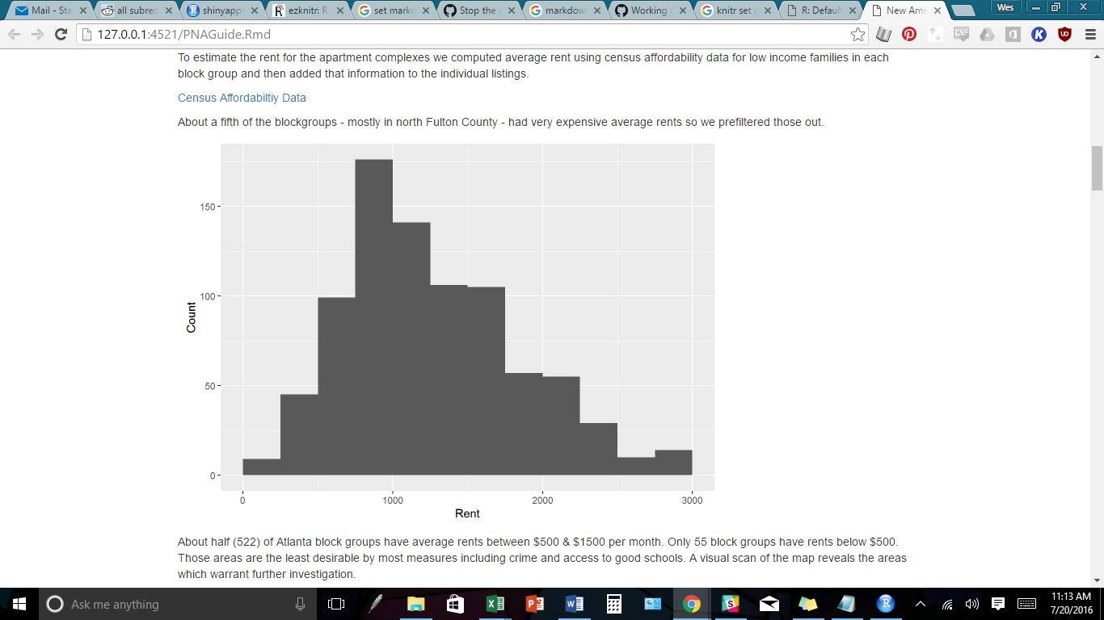

About half (522) of Atlanta block groups have average rents between $500 & $1500 per month. Only 55 block groups have rents below $500. Those areas are the least desirable by most measures including crime and access to good schools. A visual scan of the map reveals the areas which warrant further investigation.

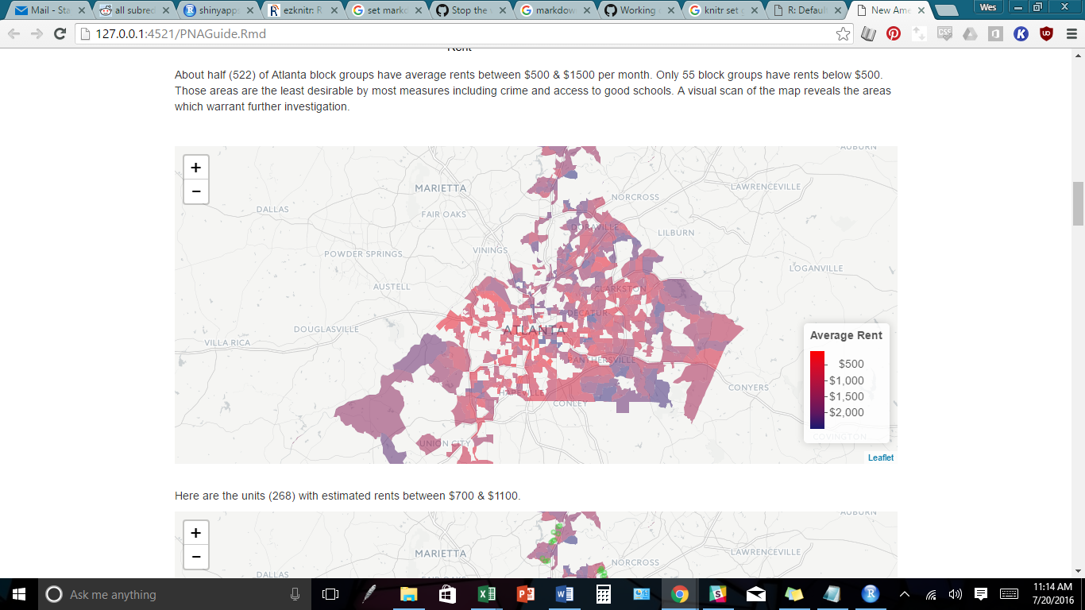

Here are the units (268) with estimated rents between $700 & $1100.

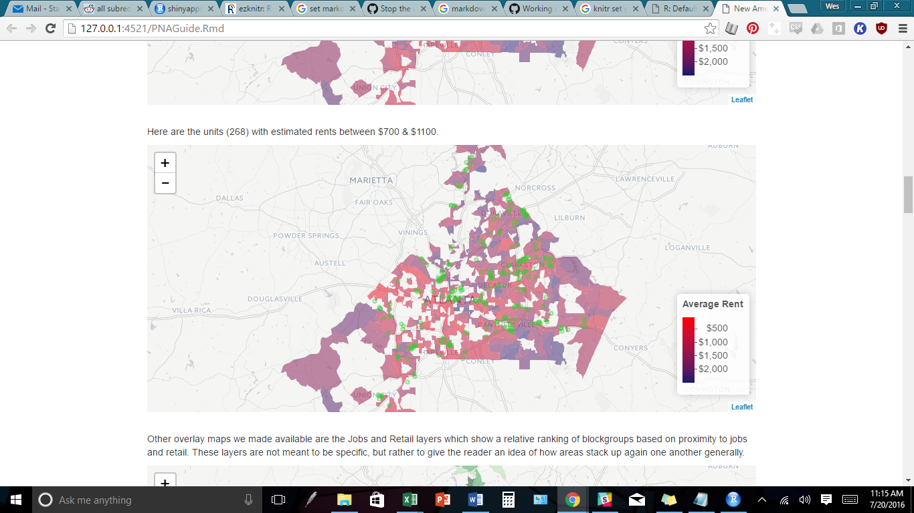

Other overlay maps we made available are the Jobs and Retail layers which show a relative ranking of block groups based on proximity to jobs and retail. These layers are not meant to be specific, but rather to give the reader an idea of how areas stack up again one another generally, i.e. the darkest green/ blue is in the top quarter of areas for jobs/ retail while the white is in the bottom quarter of areas.

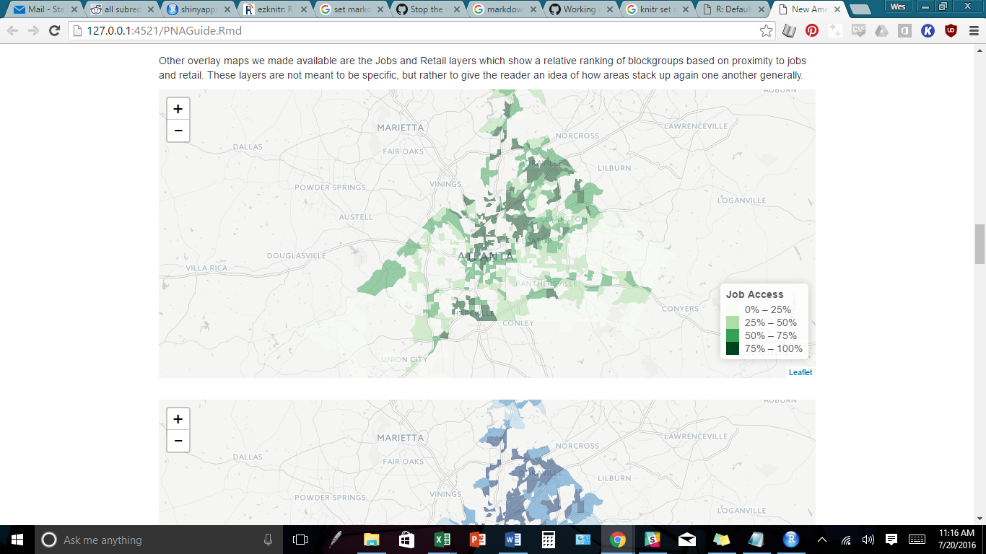

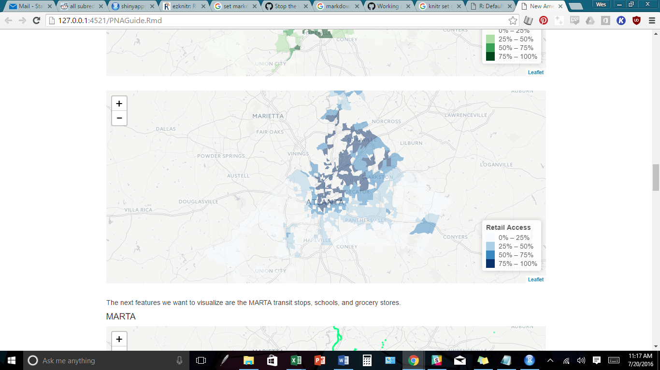

Next, we want to visualize the point features, MARTA transit stops, schools, and grocery stores.

MARTA

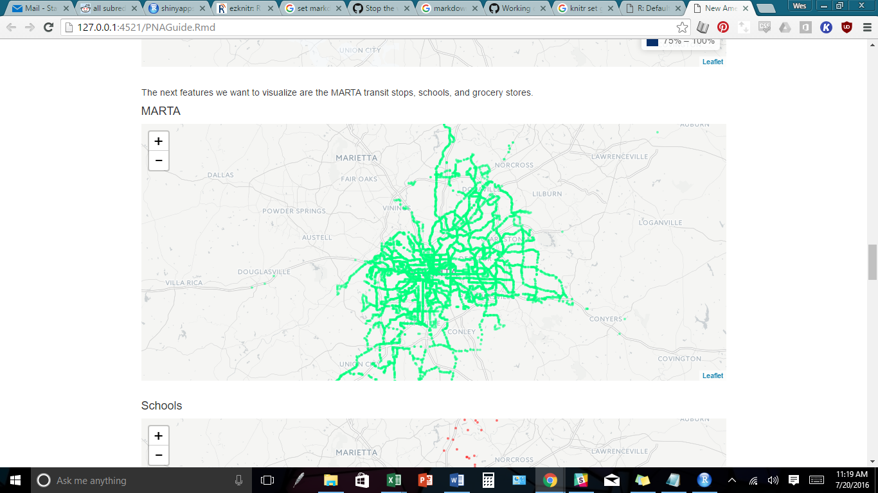

Schools

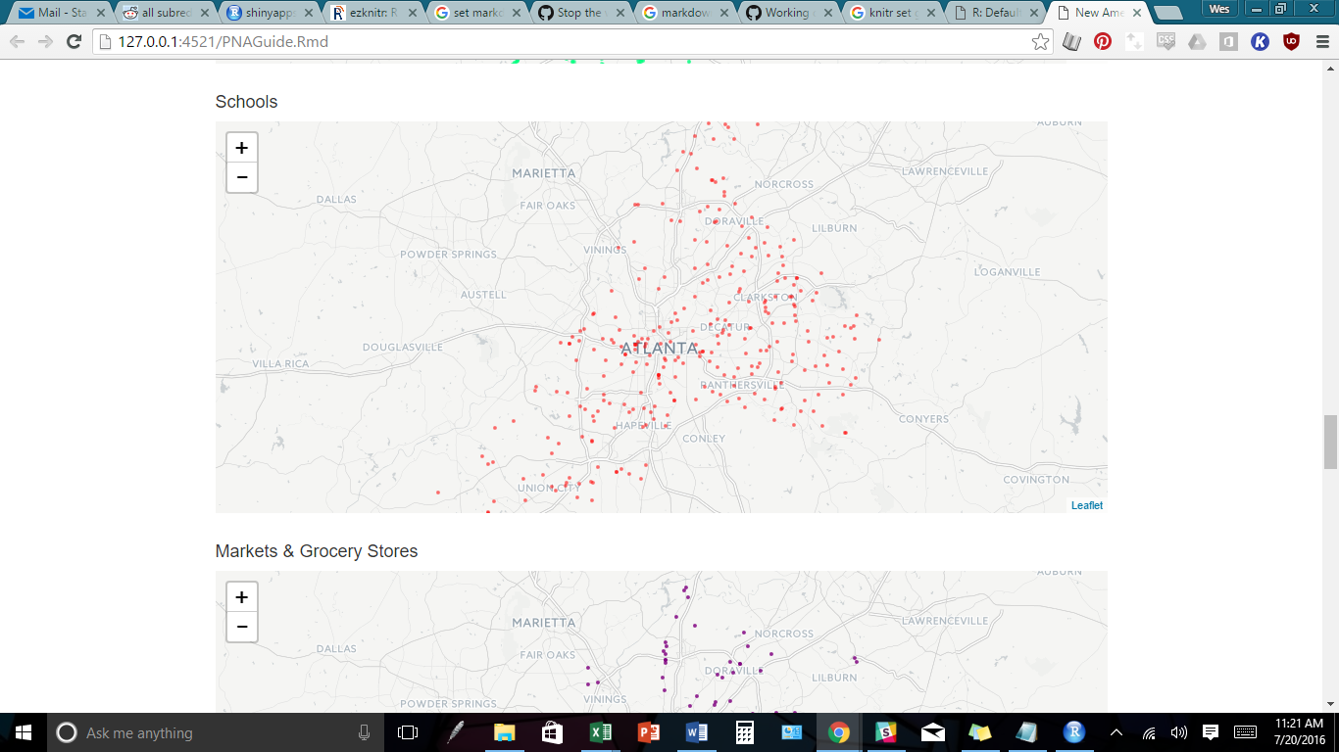

Markets

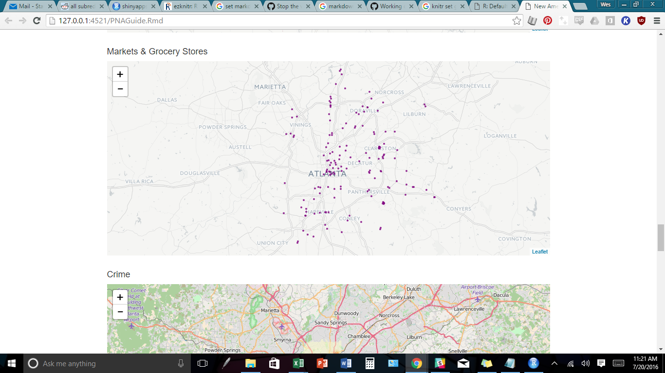

In addition to the features shown above, you can also choose to view hospitals, DFACS offices, SSN offices, and more. We recommend only viewing one or two elements at a time until you’ve identified a fairly small area to explore, otherwise the map will get cluttered quickly.

Dynamic Heat Mapping

In the map below is a custom generated raster image incorporating all of the elements in our search. You can choose - via the selector bars on the left panel - how important each of the factors (affordability, retail, jobs, markets access, and transit access) will feature in the map. While using the layers are more clearly defined, the heat map will allow you to explore the interplay of the area features.

In order to access the feature, select “Show Weighted Map” under the Show options. You’ll want to set your base layer to default in order to prevent layer overlap which will result in a confusing color scheme.

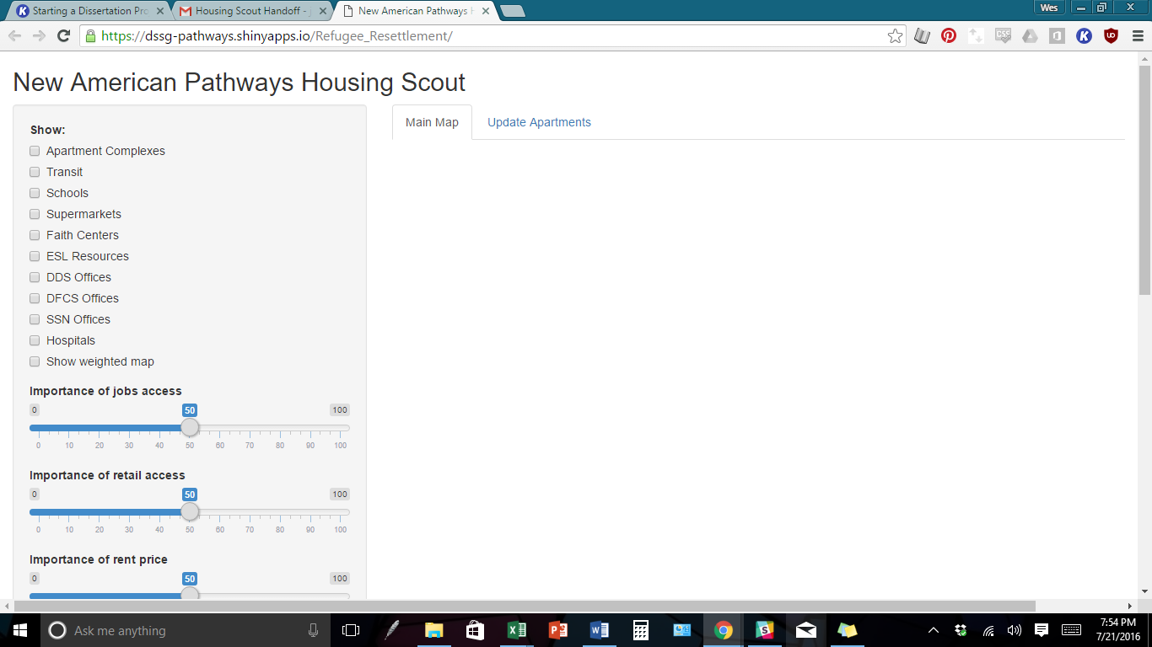

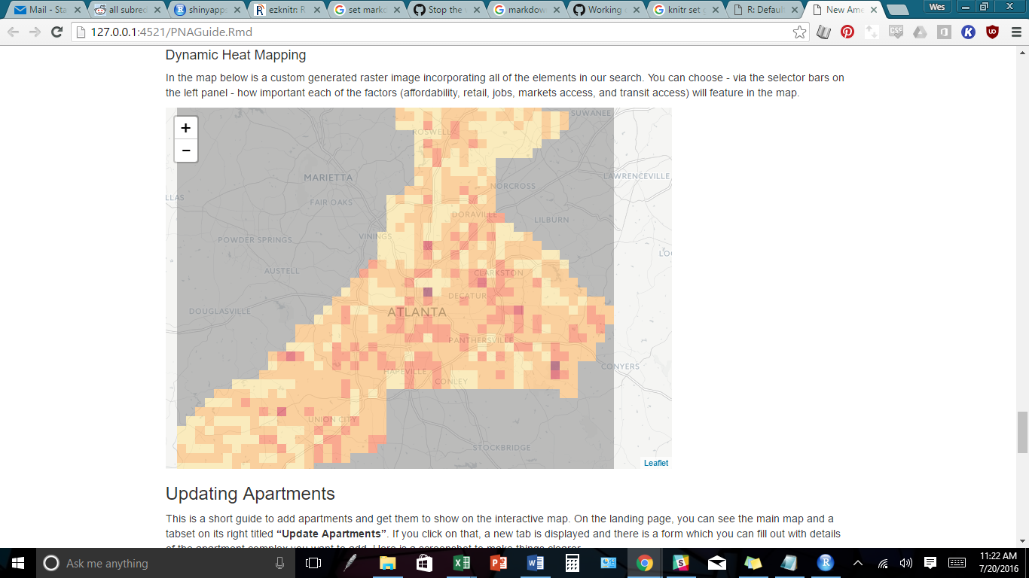

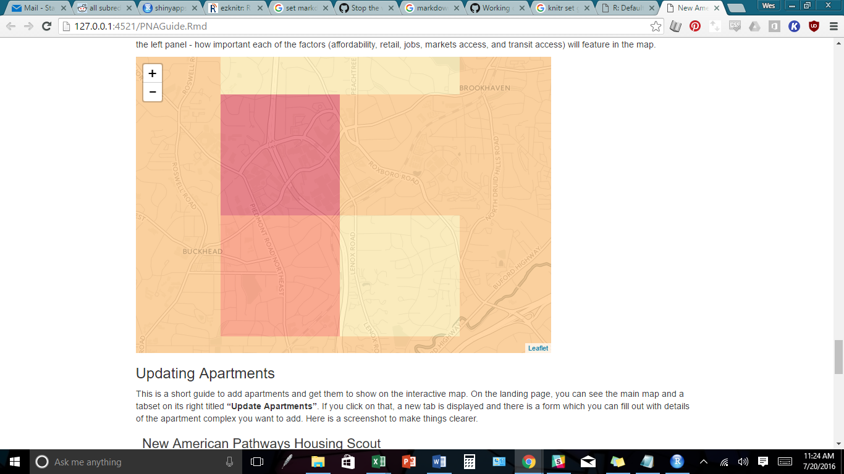

### **Updating Apartments**

This is a short guide to add apartments and get them to show on the interactive map. On the landing page, you can see the main map and a tabset on its right titled **“Update Apartments”**. If you click on that, a new tab is displayed and there is a form which you can fill out with details of the apartment complex you want to add. Here is a screenshot to make things clearer.

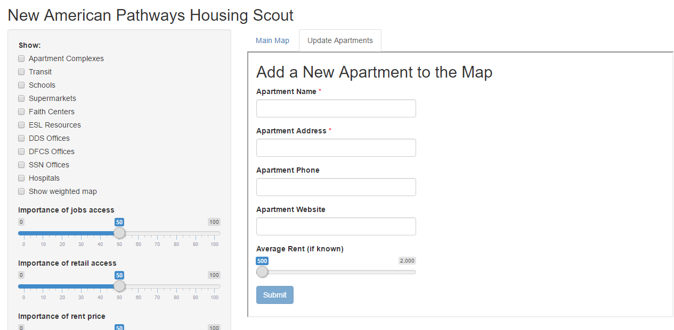

In this form, there are two mandatory fields: - Apartment Name - Apartment Address

The rest of the fields are optional. The address is especially important because it will be used later on to extract latitude, longitude information for displaying on the map.

#### After Filling Out Form

Once you press the “Submit” button, you have the option of entering more apartments by clicking on “Submit another response”. You can add any number of apartments. Your entries get recorded in a Google spreadsheet.

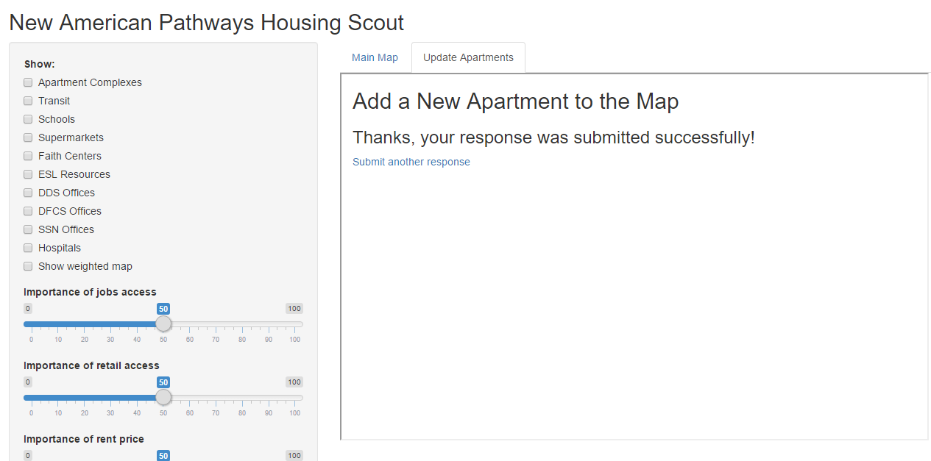

#### How to Get Updated Apartment in Interactive Tool

For that, there is a list of steps you need to follow: 1. Download R Studio

[Click here to Download for your platform](https://www.rstudio.com/products/rstudio/download/)

1. Navigate to the folder we have shared with you called “NAP2016”
2. Double click on the file “app.R”
3. Type rsconnect::deployApp() in the R Console
4. Viola! Once the app is deployed, it will reflect the new changes made (added apartments).

### **Updating All Other Data**

It is expected that places data such as schools, hospitals etc. will not need to be updated too frequently. However, after say, 6 months or so, this data can be updated using the code provided in the ‘NAP2016’ folder. We have provided python code to download all the places data and schools data into CSV files. The code files are named:

* get_google_places.py
* get_schools.py

These files contain detailed documentation as to how to obtain data using Google Places API and Great Schools API. Note: You will need to have Python installed in order to run the code. All other requirements and methods to obtain APIs are detailed in the python files mentioned above.

Another way you can obtain new data is to add it in the CSV files already present in the ‘NAP2016’ folder. All the data is contained in the ‘data’ folder. We recommend that you create a backup folder [say, ‘NAP2016_backup’] in your computer before editing the CSV files.